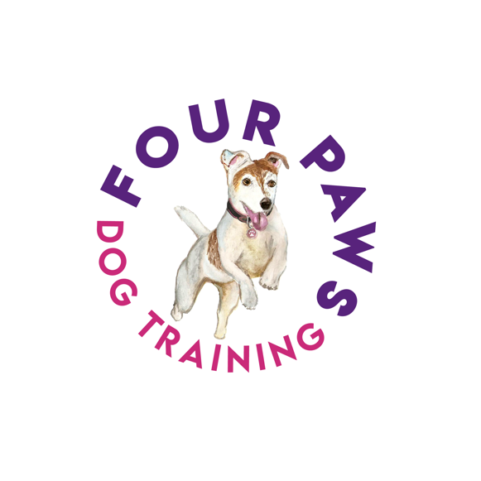
Four Paws Dog Training
Ellen Davies
Trehelig, Llangynog, SA33 5BT
07590 620552

Name.......................................................................................................
Address..................................................................................................

..................................................................................................................
Telephone (Home).......................... Mobile............................................
Email address....................... .................................................................
Emergency Contact Name and Number …………………………………..
…………………………………………………………………………………..
Pet’s Name.................................. Microchip Number………………………
Species.............................. Age..................................
Breed........................................................ Colour.....................................
Sex M / F Neutered Y / N
Service required: Doggy Daycare / Overnight Boarding / Cat Home Visits
Date from..................................... To ..................................................
Health conditions / Medications..............................................................
Feeding requirements............................................................................
Vaccinations Last Given…………………………………………………….
Last wormed.................................... Last fleatreated..............................
My pet is / is not insured
Insurance company..........................................
Veterinary Surgery Name and Number...................................................
Four Paws Dog Training
Ellen Davies
Trehelig, Llangynog, SA33 5BT
07590 620552

I do / do not give permission for my dog to be walked off lead when under the care of Four Paws Dog Training.
I do / do not give permission for Four Paws Dog Training to seek veterinary attention for my pet, if required and will settle any veterinary bills on collection of my pet. In these circumstances, any claims for veterinary fees will be covered by the owner, either by insurance or other and will not be compensated for by Four Paws Dog Training unless proved negligible on their part.
I understand and agree for my dog to be on Four Paws premises along-side their resident cats and dogs. All animals will have contact with young children residing at this premises also. There are likely to be additional dogs also staying at the premises for Day-Care and Overnight Boarding for which I am happy with.
I do not hold Four Paws Dog Training responsible for the loss or death of my pet when under their care unless proven negligent.
I agree to pay £................ Per day / hour which totals £................ for the dates stated above.
I agree to give at least 48 hours’ notice for cancellations, failure to do so will incur the full Day-care/Overnight Boarding fee.
Refunds will not be given for Day-Care, Overnight Boarding or Cat Home Visits cancelled by the client once the service has begun for the dates agreed.
I have read and agree to the Terms and Conditions of the services required for my pet, as stated above.
This contract applies to the dates as stated above as well as any services required in the future but service fees as subject to change.
To abide by the new GDPR (General Data Protection Regulation) we must ask permission to hold your details on our database. These details will be kept secure, used only in connection with Four Paws Dog Training business and will not be passed on to any 3rd party. By signing this form, you are agreeing to us holding your information as detailed above to comply with GDPR.
Signed ............................................ Date .................................... Print...............................................................................................

